**Mini Project**

***Submitted by Golmei Shaheamlung***

**Problem statement**

The Chief Minister of the state (Delhi) wants to have a detailed overview of COVID 19 in the state for the month of June 2020 to plan the strategy for safeguarding the people of the state

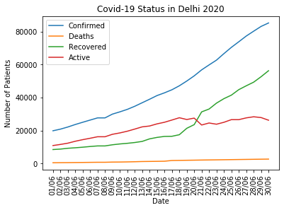

**Figure: Date wise Data detailed of Covid 19 detailed in Delhi for month of June 2020**

**Code:**

import pandas as pd

import numpy as np

import seaborn as sns

state='Delhi'

count=data['Sno'].count()

y1=[]

y2=[]

y3=[]

y4=[]

x=[]

for i in range(count):

if data['State/UnionTerritory'][i]==state:

date=(data['Date'][i])[:5]

if(int(date[3:5])==6):

x.append(date)

y1.append(data['Confirmed'][i])

y2.append(data['Deaths'][i])

y3.append(data['Cured'][i])

y4.append(data['Confirmed'][i]-data['Cured'][i]-data['Deaths'][i])

# Import the necessary packages and modules

import matplotlib.pyplot as plt

# Plot the data

plt.plot(x, y1, label='Confirmed')

plt.plot(x, y2, label='Deaths')

plt.plot(x, y3, label='Recovered')

plt.plot(x, y4, label='Active')

# Add a legend

plt.legend()

plt.title('Covid-19 Status in Delhi 2020')

plt.xlabel('Date')

plt.ylabel('Number of Patients')

plt.xticks(rotation=90)

# Show the plot

plt.show()